Project Management Plan

*Villamin Wood and Iron Works System*

Villamin Wood and Iron Works

G367+F29, MRT Ave

Taguig, 1632

May 2023

Table of Contents

Business Case 8

Problem Definition 8

Problem Statement 8

Project Overview 10

Goals and Objectives 11

Project Performance 12

Project Assumptions 13

Project Constraints 13

Major Project Milestones 14

Strategic Alignment 15

Cost and Benefit Analysis 16

Project Charter 16

Project Purpose/Justification 16

Business Need 16

Business Objectives 17

Project Description 17

Project Objectives and Success Criteria 18

Requirements 18

Constraints 18

Risks 19

Project Key Deliverables 21

Summary Milestone Schedule 21

Budget Summary 23

Project Approval Requirements 23

Project Management Approach 23

Project Technical Approach 24

Product Development Methodology 24

Technical Architecture 25

Project Management Plans 25

Stakeholder Strategy Management Plan 25

Introduction 25

Identify Stakeholders 26

Key Stakeholders 28

Stakeholder Analysis 29

Scope Management Plan 30

Introduction 30

Scope Management Approach 32

Roles and Responsibilities 33

Scope Definition 34

Project Scope Statement 34

Work Breakdown Structure 36

Scope Verification 37

Scope Control 38

Cost Management Plan 39

Cost Management Approach 39

Measuring Project Costs 40

Schedule Management Plan 41

Introduction 41

Schedule Control 43

Schedule Changes and Thresholds 43

Scope Change 44

Staffing Management Plan 44

Introduction 44

Roles and Responsibilities 45

Project Organizational Charts 47

Staffing Management 48

Change Management Plan 50

Introduction 50

Change Control Board 50

Roles and Responsibilities 52

Change Control Process 53

Communications Management Plan 55

Introduction 55

Communications Management Approach 56

Communications Management Constraints 56

Stakeholder Communication Requirements 57

Roles 57

Project Team Directory 59

Communication Methods and Technologies 60

Communications Matrix 60

Communication Flowchart 61

Guidelines for Meetings 62

Communication Standards 62

Communication Escalation Process 62

Glossary of Communication Terminology 62

Quality Management Plan 63

Introduction 63

Quality Management Approach 64

Quality Requirements/Standards 67

Quality Assurance 69

Quality Control 70

Quality Control Measurements 72

Risk Management Plan 72

Introduction 72

Top 3 Risks 73

Risk Management Approach 73

Risk Identification 74

Risk Qualification and Prioritization 75

Risk Monitoring 75

Risk Mitigation and Avoidance 76

Risk Register 77

Procurement Plan 77

Introduction 77

Procurement Risks 79

Procurement Risk Management 80

Cost Determination 82

Procurement Constraints 83

Contract Approval Process 84

Decision Criteria 86

Performance Metrics for Procurement Activities 87

Implementation Plan 88

Executive Summary 88

Transition Approach 89

Transition Team Organization 90

Workforce Transition 91

Workforce Execution During Transition 92

Subcontracts 94

Property Transition 94

Sponsor Acceptance 98

Appendices 98

Project Cost and Benefit Analysis 98

Project Methodology 98

System Requirement Specifications 99

Development Tools Specifications 99

WBS Dictionary 99

WBS Detailed Schedule 99

Detailed Cost Estimates 101

|  |  |
| --- | --- |
| **Registered Name:** | VILLAMIN WOOD & IRON WORKS |
| **Company Logo:** |  |
| **Address:** | G367+F29, MRT Ave  Taguig, 1632 |
| **Telephone Numbers:** | 8425-7962  8425-7906 |
| **Fax Number:** |  |
| **Line of Business:** | Carpentry Manufacturer |
| **Type of Customers:** | Builders, Contractors, Architects, Engineers, and Landlords |
| **Date of Registration:** | 2000 (Bureau of Internal Revenue)  2010 (Social Security System) |
| **Business Owner:** | Manuel Villamin |
| **Number of Employees:** | 12 |

Table 1. Company Profile of Villamin Wood and Iron Works

Villamin Wood & Iron Works is a Company and a provider of high-quality customized solutions in the field of woodworking, ironworking, glass fabrication, and aluminum works. With a commitment to innovation, precision quality, and exceptional customer service, we have established ourselves as a trusted name in the industry. Our company specializes in the design, customizing products, manufacturing, and installation of a wide range of products, catering to both residential and commercial clients.

**Mission:**

Our mission is to deliver superior quality and innovative solutions in the fields of woodworks, ironworks, glass fabrication, and aluminum works. We aim to exceed customer expectations by providing customized, durable, and aesthetically pleasing products that enhance the functionality and visual appeal of any space. Through our commitment to excellence, we strive to become the preferred choice for clients seeking premium manufacturing services.

**Product Offerings:**

1. Woodworks: We offer a comprehensive range of wood-based products, including custom furniture, cabinetry, kitchenware, and architectural woodwork. Our skilled craftsmen work with various wood species, traditional techniques to create products that are built to last. Traditional woodworking techniques offer unique qualities that appeal to those who value quality, sustainability, and the preservation of cultural heritage.
2. Ironworks: Our ironwork division specializes in the design and fabrication of high-quality wrought iron gates, fences, railings, window frames, and staircases. We blend traditional blacksmithing methods with contemporary design principles to produce durable, visually appealing ironwork that adds elegance and security to residential and commercial properties.
3. Glass Fabrication: With our state-of-the-art glass fabrication facilities, we offer a wide range of customized glass solutions. These include glass doors, windows, partitions, shower enclosures, and mirrors. Our skilled artisans work with precision, ensuring flawless cutting, edging, tempering, and laminating to deliver exceptional glass products that enhance both aesthetics and functionality.
4. Aluminum Works: Our aluminum works division specializes in the design, fabrication, and installation of aluminum-based solutions, including windows, doors, curtain walls, and façade systems. We offer an extensive selection of finishes and profiles, ensuring durability, energy efficiency, and architectural appeal for both residential and commercial projects.
5. Clientele: We serve a diverse range of clients, including homeowners, architects, interior designers, contractors, developers, and businesses across various industries. Our commitment to understanding and meeting our clients' unique requirements has earned us a loyal customer base and numerous successful collaborations.

# Business Case

## Problem Definition

### **Problem Statement**

The project’s business client, Villamin Wood, and Iron Works, owned by Mr. Manuel Villamin Jr. is a manufacturing enterprise where products are made to order. The company has been operational since 1983, in its span, the company’s estimated profit is 600,000 per year. The problem started when the lockdown happened due to the pandemic, which the company did not anticipate that their profit would decrease by 30%. Since then, they started to use and create their own Facebook page to help increase their clientele.

However, Villamin Wood and Iron Works’ Facebook page became outdated, and not knowing how to create an advertisement and on how to improve their page to help them market the company towards customers, other competitors covered their page.

**Organizational Impact**

There are no new roles required for this project. But existing roles will have to tend for the project to work as intended. The following are the existing roles and their responsibilities:

1. Store Manager

* Manage the product’s availability.
* Managing the System’s Database.
* Tend to the customers’ orders.
* Monitor business performance through Dashboard.

1. Store Owner

* Edit the website.
* Managing the System’s Database.
* Monitor business performance through Dashboard Reports.

**Technology Migration**

Villamin Wood and Iron Works operates in a Paper and Pen when documenting their sales and list of goods. The System Proposed by MLNSD will transition their current operations digitally in PHP and SQL. In the process, the team will continuously coordinate with the client to achieve the output desired. In line with coordinating with the client, the team created a Form for the client to fill if they have concerns, and if there are any details for the team. An interface is prepared in the system for the client to import new products. This will enable them to modify the product listing displayed independently. As of May 2023, the client has provided sixteen of their products lists that have been then migrated to the system manually in preparation for the initial deployment.

## Project Overview

The project created for Villamin Wood and Iron Works upon their request is an ordering system to help improve their current business process which is why the team developed an ordering system. Part of the goals and objectives of this project is to boost the number of customers and improve the time it takes for transactions to be completed.

As the project progresses there will be a list of project assumptions, constraints, and milestones along the way. However, the preliminary list which the team will build upon is provided below.

**Project Description**

The project which is an Ordering System will consist of features created to benefit both the client and their customers will be implemented to address the business problems of the client. Utilizing the features of the online store will help to solve the business problems.

The key features are as follows:

1. Ordering System – To provide a convenient and faster way to process and create orders.
2. Customer Sign-up/Log-in – To have accounts that can interact with the online store.
3. Admin Dashboard – To be able to monitor the sales and inventory.

### **Goals and Objectives**

The business goals and objectives supported by the project created by MLNSD are prominently observed as requested by the client (Villamin Wood and Iron Works) which is to boost the number of customers and to increase sales with the help of an online store. The project addresses those objectives by developing the online store with an ordering system and having the ability to manage stocks and view reports on the dashboard. Listed below are the specific objectives of the project:

1. To boost the number of customers by creating a convenient alternative for their Facebook page through our systems which minimizes the amount of clicks it takes to order by two clicks.
2. To create features for the system such as the add-to-cart and check-out feature which will improve the time it takes for transactions to complete from the previous 2-3 days and now can be accomplished within 1-2 days.

### **Project Performance**

A quantitative criterion to gauge the project's performance will be used to assess its success. The following criteria will be used to gauge the project's success using KPI:

1. Budget Plan –The team will look for inefficiency and waste to guarantee quality control in project management procedures. They will also monitor the construction of the project to ensure that the budget will not exceed.
2. Milestones –The team will track project progress to make sure the project is going according to plan and schedule for the project development.
3. Productivity –The productivity of the team will be monitored while they conduct their tasks and responsibilities and monitor the progress of the assigned work.
4. Team Satisfaction – The team will make sure that every team member increases productivity and does their work satisfactorily.
5. Client satisfaction – The team will offer a Client Satisfaction Survey evaluation to gauge the project's effectiveness and efficiency.

### **Project Assumptions**

1. There will be communication between the team and the company if there are complications occur upon deployment.
2. The business and the team will discuss any additional resources.
3. Additional features or changes will be added depending on the discussion and agreement between the team and the client.

### **Project Constraints**

These are the following constraints pertain to Villamin Wood and Iron works:

1. It is necessary to purchase if there are any additional requirements within the allocated budget and time limit. The group will guarantee to effectively accomplish the targets to meet the undertaking goals, and the group will guarantee to effectively accomplish the requirements.
2. The software that will be used is necessary to be compatible with our IT platforms.
3. To avoid conflict, any additional requirements should be discussed prior to the deadline.

### **Major Project Milestones**

According to the milestone schedule below, the project plan will be submitted and approved. After the project plan is approved, resources will be assigned to it. Any schedule adjustments that may affect milestones must be approved by the Project Sponsor. The project plan will include a thorough schedule.

|  |  |
| --- | --- |
| **DELIVERABLE** | **COMPLETION DATE** |
| MVC Infographic | September 25, 2022 |
| Project Charter Plan | January 1, 2023 |
| Statement of Work | January 24, 2023 |
| Project Vision and Scope | January 19, 2023 |
| Activity List | February 23, 2023 |
| Work Breakdown Structure | May 3, 2023 |
| Quality Management Plan | February 15, 2023 |
| User Project Review | February 13, 2023 |
| Test Case | February 13, 2023 |
| Quality Management Plan | February 15, 2023 |
| Software Requirement Specification | February 17, 2023 |
| Business Case | April 13, 2023 |
| Stakeholder Analysis | April 13, 2023 |
| Stakeholder Management Strategy | April 13, 2023 |
| Cost Management Plan | May 3, 2023 |
| Schedule Management Plan | May 3, 2023 |
| Scope Management Plan | May 3, 2023 |
| Work Package Solution | May 3, 2023 |

Table 2. Major Project Milestones

## Strategic Alignment

By ensuring that the Ordering System is in line with Villamin Wood and Iron Work's strategic goals and objectives, the team MLNSD will optimize the project's value and guarantee its contribution to the company's long-term success.

*Villamin Wood and Iron Works aims to deliver superior quality and innovative solutions in the fields of woodworks, ironworks, glass fabrication, and aluminum works.*

* A flexible, scalable ordering system that can support the development and growth of the company in the future. The ordering system allows customers to customize orders based on their specific requirements. This flexibility is crucial, as it aligns with the company's commitment to delivering unique, tailored quality. The system should enable customers to choose from a range of options, such as design elements, finishes, sizes, and materials for iron, glass, and aluminum works.

*Villamin Wood and Iron Works aim to exceed customer expectations and enhance the functionality and visual appeal of their products.*

* By aligning with this goal, an ordering system is a customer-centric approach that enhances the customer experience and provides convenience. The ordering system is designed to be user-friendly and intuitive and includes features that make it simple for clients to place orders and track progress.

*Villamin Wood and Iron Works strive to become the preferred choice for clients seeking premium manufacturing services.*

* By aligning the ordering system with the strategic goals of the company of becoming the preferred choice for premium manufacturing services, the ordering system will enhance the overall customer experience by allowing customers to easily navigate through the process. Incorporate features such as real-time order tracking and customization. Lastly, by improving operational efficiency to optimize the workflow and automate processes within the ordering system to minimize errors, reduce lead times, and improve overall operational efficiency.

## Cost and Benefit Analysis

As the objective implies, 50% of customer reach is targeted for this project's success, if most of those new customers purchased a product, we could put in. This table is not final, and this is introduced for the client’s approval:

# Project Charter

## Project Purpose/Justification

### **Business Need**

The Villamin Wood & Iron Works System has been created to help the company increase their sales and customer reach to take back the loss in income from the sudden temporary closing of shop due to the pandemic. Also, to enhance the conveniency of their customers. In this approach, it will eliminate unnecessary expenses of the company. The cost to make the system successful will be covered by the company owner, recovered by the system's anticipated results.

### **Business Objectives**

1. Strengthen customer service.

* Develop goals that motivate them and ensure that our customers and clients have a positive experience with our services. And emphasize the importance of providing an exceptional customer experience every time we connect with our customers and clients.

1. Sell a more reliable product.
   * Our company will set quality and troubleshooting goals to identify areas for improvement within our products. With this, we will be able to give constant enhancements and upgrades based on the demands of our clients.

## Project Description

The Villamin Wood & Iron Works System will support the increase in the company’s sales and customer reach. The system will provide easy navigation and transaction to avoid complications while customers are using the system. The system will be an additional tool from the company’s current platform to attain their objectives while allowing customers to browse and process orders easily.

### **Project Objectives and Success Criteria**

*Constraints*

These are the following constraints pertain to Villamin Wood and Iron works:

1. It is necessary to purchase if there are any additional requirements within the allocated budget and time limit.

2. The stakeholder will provide the necessary information for the project.

The software to be used must be suitable for our IT (Information Technology) platforms.

*Assumptions*

1. There will be communication between the team and the company if there are complications occur upon deployment.

2. If there are more resources, the company and the team will discuss.

### **Requirements**

### **Constraints**

These are the following constraints pertain to Villamin Wood and Iron works:

* + - It is necessary to purchase if there are any additional requirements within the allocated budget and time limit.
    - The stakeholder will provide the necessary information for the project.
    - The software to be used must be suitable for our IT (Information Technology) platforms.

**Assumptions**

* + There will be communication between the team and the company if there are complications occur upon deployment.
  + If there are more resources, the company and the team will discuss.

**Preliminary Scope Statement**

This project created by the MLNSD team will include designing, improving, testing and delivery of an improved online ordering system for the client, Villamin Wood & Iron Works. The improved system will require internet use to capture the orders and training of the client's staff to manage and administer the website. The project will conclude once the system is ready for deployment.

## Risks

The following risks are what the team has foreseen that could affect the performance output of the project proposed:

* Denial of service
  + Web Services that are not accessible to the users, render potential loss of profit.
  + A factor that causes Denial of Service is web traffic entering the system. When the system has received user requests beyond its capacity, it may lead to a system crash.
  + Malicious attacks also play a role. In which hackers flood/overflow the request, impair the servers, and cause inoperability.
  + Not only will customers suffer from the system's malfunction caused by external factors, but the company's workforce will not be able to complete the tasks required to fulfill the needed output.
* SQL injections
  + Hackers use this technique to alter the desired algorithm (within the source code) by the developers. This in return gives more control to them. It also increases the company's system vulnerabilities.
* Data breach
  + Data breach is a process of hackers collecting data without any form of authorization from the product owners. The data can be used to damage the company and its stakeholder's reputation for the benefit of the infiltrator.
  + Despite having numerous methods of attacks (such as, insider leak, loss or theft of information, and unintended disclosure), the prior risks may also be a factor that may contribute to this.
* Cybersquatting
  + Cybersquatting is a way for external affairs to take advantage of the websites' domain.
  + Cybersquatters manipulate the reputation and domain of the company and use it to redirect users to a different service and/or platform.

With the listed risks, the team will collaborate with the stakeholders and ensure that the foreseen risks will be tended to. In preparation to reinforce the project based on the risks listed, the team will create solutions that are aligned with the project budget and constraints. If the risks were to affect the system, the team will ensure this is managed with immediate response.

## Project Key Deliverables

Following the project's successful conclusion, the following deliverables must be met. These deliverables cannot be altered without the project sponsor's consent.

* Product
* Logo

## Summary Milestone Schedule

Below is a summary of the project's milestone schedule. This timeline may change as requirements become more specified. The project manager will convey any modifications through project status meetings.

|  |  |
| --- | --- |
| Summary Milestone Schedule – List key project milestones relative to project start. | |
| Project Milestone | Target Date  (mm/dd/yy) |
| Project Start | 3/30/22 |
| Planning   * Midterm Presentation * Finals Presentation | 5/2/2022  6/7/2022 |
| Analysis and Design   * MVC Infographic * Flow of Activities (Diagrams) * Initial Working Prototype | 9/29/22  10/28/22  11/15/22 |
| Development, Testing, and Deployment   * GitHub Repository * Project Charter Plan * Project Scope and Vision * Quality Management Plan * Software System Requirements | 12/15/22  1/12/23  1/15/23  2/15/23  2/20/23 |
| Project Complete | 2023 |

Table 3. Summary Milestone Schedule

## Budget Summary

The graphic below depicts a project budget summary, including the proposed cost. type, description, and their anticipated expenses. This budget is required for the project to be completed successfully. The budget for the System project is ? It is to be funded through the Villamin Wood and Iron Works Budget.

## Project Approval Requirements

The project will be considered successful when everything is completely deployed during the project's life span within the time restrictions specified in this charter. Furthermore, as we fully anticipate the need for this solution to evolve to avert future threats, this measure of success must contain a list of recommendations for consideration. The Project Sponsor, Mr. Manuel Villamin Jr., who will also approve the project's conclusion, will determine its success.

# Project Management Approach

The Project Sponsor has complete power over the execution of plans and any necessary revisions. The Project Manager, on the other hand, oversees supervising and executing the project in accordance with the Project Plan. Personnel from the administrative, product development, and quality assurance groups will make up the project team.

To complete project planning, the project manager will collaborate with all resources. The project sponsor will examine and approve all project and subsidiary management plans. The project sponsor will also make all financing decisions. Any delegation of approval authority to the project manager should be documented and approved by both the project sponsor and the project manager.

# Project Technical Approach

Our technological approach for Villamin Wood and Iron Works System is based on a thorough understanding of the project requirements and constraints. Our team will use an agile product development methodology to assure on-time delivery of a high-quality solution that fulfills the client's expectations.

## Product Development Methodology

Our product management strategy is based on an agile project management framework. We will use an agile approach to allow for quick iterations and ongoing feedback from stakeholders, as well as to ensure that the project is completed on time and within budget.

The steps in the methodology are as follows:

1. Project Initiation

2. Planning

3. Execution

4. Closure

We will maintain ongoing communication with the client throughout the product development life cycle to ensure that the project stays on track and satisfies their needs. We will also focus on user experience and design to ensure that the product is easy to use.

## Technical Architecture

Video provides a powerful way to help you prove your point. When you click Online Video, you can paste in the embed code for the video you want to add. You can also type a keyword to search online for the video that best fits your document.

# Project Management Plans

## Stakeholder Strategy Management Plan

### **Introduction**

The objectives and guiding principles for Villamin Wood and Iron Works' participants, staff, and employees are outlined in this paper. It provides a strategic plan to guarantee Villamin Wood and Iron Works' recognition as well as its continued growth and expansion.

The organization must contribute to defining and enabling modern technology in a world marked by risk and uncertainty as well as an enormous opportunity. We think Villamin Wood and Iron Works is in an outstanding position to acquire the necessary abilities in all project participants and to have a business strategy that will assist the company's growth.

Villamin Wood and Iron Works affiliates directly contributed to the creation of our Strategic Plan for 2022–2023. Thus, the plan invites all stakeholders to actively participate as we build on our strengths, fix our flaws, and strive to reach our potential.

### **Identify Stakeholders**

|  |  |  |  |  |  |
| --- | --- | --- | --- | --- | --- |
| STAKEHOLDER | ROLE | INTEREST LEVEL  H/L | EXPECTATIONS | ACTIONS REQUIRED | CONTACT |
| Manuel C. Villamin Jr. | Business Owner | H | Detailed efficient plans and strategies for business operations | Consult with stakeholder and provide company’s information | villaminmcverv@gmail.com |
| Mabelle Aspeli | Project Manager | H | Acquire and approve the required documents that should be approved by the stakeholder. Follow up questions to the client if there are clarifications. | Align stakeholders around the vision of the product | mtaspeli@student.apc.edu.ph |
| Leigh Curtis Camara | Team Leader | H | Timely updates on project progress. | Delegate tasks and set deadlines | lbcamara2@student.apc.edu.ph |
| Sofia Emmanuelle Villamin | Project Stakeholder | H | Reports and details of client’s demand. | Provides resources and support for the project | srvillamin@student.  apc.edu.ph |
| Nathaniel Sison | Team Developer | H | Obtain project requirement and client’s demand | Consult with team leader and stakeholder to execute suitable requisite. | nmsison@student.  apc.edu.ph |
| Dale Joshua Domingo | Team Secretary | L | Detailed records of problems that appear during testing | Facilitate and schedule team meetings. | dbdomingo@student.  apc.edu.ph |
| Ludwig Marco Angeles | Team Secretary Support | L | Observe or participate in product testing | Write and provide observation on product testing. | ltangeles@student.apc.edu.ph |

Table 4. Stakeholders

### **Key Stakeholders**

|  |  |  |  |
| --- | --- | --- | --- |
| STAKEHOLDER | ROLE | RESPONSIBILITIES | COMMENTS |
| Mabelle Aspeli | Project Manager | Principal responsible party for the project's accomplishment. Work plan, resource allocation, risk management, scope change management, milestones monitoring, and project status communication with all stakeholders. | Notifies the Team Leader of any escalating risks, problems, or personnel difficulties. |
| Leigh Curtis Camara | Team Leader | A person who leads, oversees, and manages a team of workers to accomplish objectives that advance the organization. | Authority to handle challenges, risk, and conflicts. |
| Sofia Emmanuelle Villamin | Project Stakeholder | A person who is responsible for facilitating the project's success and provides resources and support. | Aim to remove eliminate barriers and approves the final plan. |
| Nathaniel Sison | Team Developer | A person in charge of organizing a functional or technical area's work. | Emulate client's demand and develops the project. |
| Dale Joshua Domingo | Team Secretary | A person in the position of setting up meetings, managing paperwork, and replying to communications. | Maintains the team's efficiency and organization. |
| Ludwig Marco Angeles | Team Secretary Support | A person who is in control of performing project duties to meet its goals. | Updates the Team Leader and Project Manager on their work's progress as well as any relevant risks or difficulties. |

Table 5. Key Stakeholders

### **Stakeholder Analysis**

|  |  |  |  |  |
| --- | --- | --- | --- | --- |
| STAKEHOLDER | ROLE | IMPACT  How much does the project impact them?  (Low, Medium, High) | INFLUENCE  How much influence do they have over the project?  (Low, Medium, High) | WHAT IS IMPORTANT TO THE STAKEHOLDER? |
| Manuel C. Villamin Jr. | Business Owner | High | High | Providing detailed and efficient plan to support the development of the team |
| Mabelle Aspeli | Project Manager | High | Medium | Keeping all stakeholders informed, involved, and on board throughout the project’s development |
| Leigh Curtis Camara | Project Manager | High | Medium | Ensuring that all parties involved can cooperate to accomplish the organization's aims and objectives. |
| Sofia Emmanuelle Villamin | Project Stakeholder | High | High | Keeping them informed and updated per client request. |
| Nathaniel Sison | Team Developer | High | High | Keeping them informed and updated per client request. |
| Dale Joshua Domingo | Team Secretary | High | Medium | Keeping the deliverables organized and efficient. |
| Ludwig Marco Angeles | Team Secretary Support | High | Medium | Maintaining work and support to the team throughout the project’s development. |

Table 6. Stakeholder Analysis

## Scope Management Plan

### **Introduction**

The Villamin Wood and Iron Works System plan for scope management describes the technologies and resources that will be used to create, document, and handle the project's context. The team will utilize agile methodologies and collaborative tools to build an ordering system that meets the project's demands.

1. Collect Requirements – To gather and record the system's requirements, the project team will employ a variety of methods, including client interviews and discussions.

1. Define Scope – To establish the scope, the user stories and scope statement will be integrated into a project management plan. The plan will be revised periodically to accommodate any modifications in the project's scope during its advancement.
2. Verify Scope – The project group will utilize an agile methodology to test and confirm that the expectations of the undertaking meet the necessities and line up with the scope statement.
3. Control Scope – A formal change control process will be used to manage any changes to the project's scope. This process will look at how these changes will affect the project's schedule, budget, and quality. Additionally, each change solicitation guarantees that the change is fundamental, practical, and lined up with the project objectives.
4. Create WBS – this process breaks project deliverables down into progressively smaller and more manageable components which, at the lowest level, are called work packages. This hierarchical structure allows for more simplicity in scheduling, costing, monitoring, and controlling the project.

### **Scope Management Approach**

The Project Manager, Mabelle Aspeli, will have the authority and responsibility to manage scope management. Mabelle Aspeli will collaborate with the project sponsor, Mr. Manuel Villamin Jr, to establish and regulate the project's scope.

1. The extent of the project will be assessed and confirmed by reports, frequent assessments of the project's advancement in comparison to the initial scope, and evaluation of the project's performance. If there are any variations from the initial scope, they will be identified and resolved through the scope change procedure.
2. Throughout the Villamin Wood and Iron Works process, the scope of the project will change, the Project Manager will have to accommodate a change request, and the project sponsor will give the final approval. To ensure that they align with the project objective and do not adversely affect the schedule or budget, any changes to the project scope must be thoroughly evaluated.
3. It is the duty of the Project Manager to make sure that all project requirements have been met so that the final deliverables are accepted and approved by the stakeholder and the project sponsor. Once all the deliverables are accepted and any remaining issues are resolved, the successful completion of the project will be confirmed.

### **Roles and Responsibilities**

Project Manager – It is the responsibility of the Project Manager to manage and authorize modifications to the project's scope, as well as to establish and record the project's scope.

Project Sponsor – Project Sponsor will have the authority to approve all changes, particularly in project budget, schedule, and project scope.

Project Team - The project team’s responsibility is to verify the scope of the project and to ask any relevant questions regarding modifications that have been submitted.

Stakeholder - Stakeholders are responsible for providing their insights into the project's requirements and scope as well as authorizing any necessary changes to the scope.

### **Scope Definition**

The team developed the project Villamin Wood and Iron Works System to build a system that resolves all the issues presented by the client and to meet their demands which includes the following:

1. Creating an Ordering System in the online store to address the conflicts with their manual ordering process.

2. Increasing the customer reach.

3. Monitor the inventory of stocks and orders.

The process of developing the detailed description of this project and its deliverables occurred through interviewing with the client and learning about their business process and understanding their struggles and how we can contribute to their business by providing the project. Team meetings discussing and developing a plan is an important process in the development of the project as we identified all requirements, scope of the project, and how we can incorporate our ideas into the system.

### **Project Scope Statement**

Product Scope Description – The project will accomplish all requests made by the client based on the business problems they have provided which should be solved by the project.

Product Acceptance Criteria – Part of the acceptance criteria will be based on the overall satisfaction of the client. This can be broken down into specific parts which includes the deployment of a fully functioning online store, solving all the presented business problems, and catering to the needs of the customers through the online store.

Project Exclusions - The following is out of the scope of the project and will not be included:

a. Modification of the system beyond what was discussed in the project scope statement.

b. Collaborations with other system/company outside of the scope of the project.

Project Constraints - The following limits the project:

a. Limited budget

b. Availability of tools to use

c. Manpower

Project Assumptions - The following assumptions have been made about the project:

a. The project timeline will be followed.

b. The project will stick to the discussed budget.

c. The system will be fully functional and accessible to the client.

### **Work Breakdown Structure**

The Work Breakdown Structure (WBS) is a hierarchical representation of the project scope that breaks it down into smaller, more manageable pieces. Starting with the highest level and working down, each level in the WBS represents a progressively more thorough view of the project. The WBS Dictionary is a companion document to the WBS that contains specific information about each component in the WBS, such as the scope of work, deliverables, responsibilities, and any other pertinent information.

The project team will split the project scope using the WBS and WBS Dictionary. Smaller, more manageable components, as well as assigning responsibilities to each component. This will help to guarantee that all areas of the project are considered and addressed and that everyone in the team understands their role in the project's completion. The schedule and The WBS Dictionary will also be used to track progress, detect, and address issues, and ensure quality that the project remains on track and within its budget. Overall, the WBS and WBS Dictionary are effective. Tools for managing project scope and guaranteeing project success are required.

### **Scope Verification**

In ensuring that the deliverables are verified leading to the formal acceptance of the project, the team will use the following methods for scope verification:

Quality checklists – This list will check that the requirements are being fulfilled and verify that they pass the standards to advance to the next deliverable.

Work performance measurements – The team will keep track of the progress of every deliverable, assuring that every member is contributing and fulfilling their roles in the development of the project.

Scope baseline – This is used to ensure that the deliverables will meet the scope and make sure that it maintains the original project scope despite changes being implemented.

Formal Acceptance – The acceptance of both the project sponsor, other stakeholders and the team is needed for the completion. This ensures that the team has met the demands and expectations of the client. That is why it is essential that there are consistent meetings and communications to ensure that the project and deliverables go as planned.

### **Scope Control**

As part of the scope control process, the project's progress and outcomes will be evaluated on a regular basis to make sure they still adhere to the project scope that is stated in the Project Scope Statement. Any deviations from the scope will be assessed, and if fundamental, the changes in the scope will be documented and still follow the procedure in the existing scope. Monitoring and managing will be the responsibility of the project manager alongside the team and stakeholders. The project manager will be reviewed on a regular basis to make sure that the project progress is still being followed.

The following steps will be taken to modify the scope baseline during the scope control process for the Villamin Wood and Iron Works System project:

1. The request for a change in scope will be evaluated by the Project Manager and the Project Sponsor to assess its potential impact on the project schedule, financial plan, and available resources.

2. Any stakeholder or team member who identifies a requirement for a change to the scope will initiate a scope change request.

3. If the request is approved, the Project Manager will create a plan of action to implement the change, revise the initial project scope, and communicate the change to all relevant stakeholders.

4. The project team will continue with the original scope if the request is rejected.

## Cost Management Plan

### **Cost Management Approach**

To facilitate a cost management plan, the team will imitate the key components of the management approach, and these are:

Cost Planning - The team will develop a comprehensive cost plan that includes budgeting, estimating costs for resources, and establishing cost baselines.

Cost Estimation - The team will determine the expected costs of project activities, tasks, or resources using various techniques such as data analysis, expert judgment, and parametric estimation.

Cost Control - The team will monitor and track costs against established baselines, identifying deviations and taking correctives within the planned limits.

Cost Analysis - The team will analyze cost data to identify trends, patterns, and opportunities for cost reduction or optimization. This may involve conducting a cost-benefit analysis, or variance analysis.

Cost Optimization - The team will seek ways to optimize costs by identifying cost-saving opportunities, improving efficiency, and exploring alternatives while considering the desired quality and performance.

Cost Reporting - The team will generate regular reports and updates on cost performance, including actual costs incurred, forecasted costs, and variance analysis, to keep stakeholders informed and facilitate decision making.

Risk Management - The team will assess and manage potential risks that could impact costs, such as cost overruns, schedule delays, or changes in scope. Mitigation strategies are developed to minimize the impact of risks on project costs.

### **Measuring Project Costs**

The cost change control process will follow the established project change request process. Approvals for project budget/cost changes must be approved by the project sponsor.

## Schedule Management Plan

### **Introduction**

The schedule management plan is a roadmap for the process of executing the project. This is important as they provide the status of the project to the project team, sponsor, and stakeholders. The purpose of the schedule management plan is to specify the methodology the project team will employ in putting together the project schedule. The schedule management plan must be identified, analyzed, documented, prioritized, approved, or rejected, and published. This plan will help the team to monitor the progress of the project and manage the changes to the project schedule after being approved.

**Schedule Management Approach**

The schedule management plan will be created with the help of the deliverables in the Work Breakdown Structure (WBS). The specific work packages that must be carried out to complete each deliverable will be identified by the activity definition. To determine the order of work packages, an activity sequencing will be used and assigned between project activities. The number of work periods necessary to finish work packages will be determined using activity duration estimation. To finish schedule development, resource estimating will be used to allocate resources to work packages.

Once an initial schedule has been done, the project team and stakeholders will review the task and must agree on the proposed work package assignments, duration, and schedule. Afterwards, the project team will have it reviewed by the project sponsor for the approval and have the schedule baselined.

The milestones for the projects schedule are as follows:

* Completion of deliverables
* Completion of scope management plan and Work Breakdown Structure (WBS)
* Approval of initial schedule baseline
* Project Sponsor budget approval
* Roles and responsibilities approval
* Acceptance of deliverables

Schedule development roles and responsibilities are the following:

* **Project Manager –** responsible for facilitating and checking the progress of the deliverables. The project manager also supports the team, stakeholder, and project sponsor on validating the proposed schedule.
* **Project Team –** responsible for working and completing the deliverables. The project team is also responsible for reviewing the proposed schedule and assigning activities after the schedule’s approval.
* **Project Stakeholders –** responsible for reviewing of proposed schedule and assisting in approvals.
* **Project Sponsor -** responsible for reviewing of proposed schedule and approval of the final schedule before baselined.

### **Schedule Control**

The project schedule will be reviewed and updated on a twice a week basis with actual start, actual initial completion, and the final completion percentage which will be given and reviewed by the Project Manager. Additionally, the project manager will be responsible for holding meetings for the updates and reviews, submission of schedule change requests, and reports of the schedule status according to the project’s communication plan.

The project team will be responsible for participating in the meetings for updates and reviews, reporting any changes of actual start and actual initial completion to the project manager.

The project sponsor will be responsible for maintaining the acknowledgement of the project schedule status, review and approve any schedule change requests that will be submitted by the project manager.

### **Schedule Changes and Thresholds**

If there is a need for a change in the schedule, the team must hold a meeting with the project manager and identify the proposed changes as they will affect the tasks in progress. While holding the meeting, the team must identify the cause of change and other changes and find a way of taking an alternative action to use for the success of the proposed scheduled plan. Afterwards, the project manager may review the proposed changes and submit the schedule change request form to the project stakeholders and project sponsor.

### **Scope Change**

The project team will need to assess the impact of any changes to the project scope that have been approved by the project sponsor on the current schedule. The project manager may request that the schedule be re-baselined to consider any changes that must be made as part of the new project scope if it is determined that the scope change will significantly affect the current project schedule. This request must be reviewed and approved by the project sponsor before the schedule can be re-baselined.

## Staffing Management Plan

### **Introduction**

Having a strong project team that will manage and help structure the project is what human resource management strategies are. It is one of the most crucial parts to the success of the project, as it is help assist in establishing the appropriate and qualified people that will work on the project. This strategy includes the roles and responsibilities, communication protocols, and performance management issues.

With the use of this plan, the team can successfully manage the project as it will make sure that all team members are working effectively and understands their role and responsibilities, that communications are open, that their performance while working is monitored as their contribution to the success of the project.

### **Roles and Responsibilities**

For the project to be completed successfully, a strong human resources management strategy is essential of any project. It describes the duties and responsibilities of each member of the project team, stakeholders, making sure that everyone is aware of their contributions and how they fit into the overall picture.

The strategy also specifies the degree of authority and decision-making held by each team member, making sure that resources are distributed and used efficiently. By distinctly defining the strategy will ensure that the appropriate individuals are in the right positions based on their competencies and skill requirements to the appropriate roles to ensure project success.

This plan acts as the success of the project roadmap for the project team to execute and deliver.

|  |  |  |  |
| --- | --- | --- | --- |
| Roles | Authority | Responsibility | Competency |
| Project Sponsor | Approves the needed deliverables and budget of the project.  Provides feedback and comments on what can be improved.  Able to allot project resources and consent to project scope changes,  schedule and budgeting plan with significant effects. | Ensures that the project delivers the anticipated benefits and value and is in line with the organization's strategic goals and objectives.  Provide guidance to the project and project manager.  Communicate with the stakeholder and project manager for the progress of the project and team. | Communicating effectively with the team.  Strong leadership and strategic thinking skills.  Understands the team’s goal for the project.  Ability to support the project. |
| Project Stakeholder | Checks the approved changes in the deliverables. Authority to revise an information that will mislead the goals of the project. | Ensures that the deliverables are complete before sending and having it checked by the project sponsor.  Organize meetings with the project manager and project team members for the feedbacks of the project sponsor. | Strong leadership, communication skills, and project management skills.  Knowledge of the company for precise information. |
| Project Manager | Authority to make decisions regarding the project.  Approve changes to project scope, schedule, and budget that has low change effect. | Control and help execute a solution to a problem in the project and monitors the work of the team members. | Strong leadership, communication skills, and project management skills. Knowledge of the company for precise information. |
| Project Team Leader  (Internal User) | Leads the team members.  Authority to call a meeting with the project manager and team members about the project. | Ensures that the entire project deliverables are complete. | Strong leadership, communication skills, and project management skills. Knowledge of the company for precise information. |
| Project Team Members  (Internal Users) | Authority to help the project leader and project manager in deciding the plans on the project. | Ensures that the information in the deliverables is complete and connected to the objectives of the project.  Ensures that the deliverables are complete within the given time limit. | Effective communication skills, project management skills, and cooperation.  Knowledge of the company needs, and information to complete deliverables. |
| Customers  (External Users) | Evaluate the project’s system. | Provides feedback on the project’s system.  Communicates with the team to help improve the system. | Communication skills.  Knowledge in using an online system. |
| Client  (External User) | Company Owner that introduced the project and will evaluate the system. | Provides feedback on the deliverables and system. Communicates with the project sponsor, project stakeholder, and project manager for updates and progress. | Strong leadership, communication skills, and negotiation skills. |

Table 7: Staffing Management Plan Roles and Responsibility

### **Project Organizational Charts**

Project organizational chart is a visual representation of the relationship between the team and the key stakeholders. At the top of the chart comes the project sponsor, followed by the project stakeholder as they are responsible for communicating between the project sponsor and the rest of the team, and then followed by the project manager which is responsible for managing the project team, send approval requests for the deliverables, and schedules. The project team members are responsible for completing the deliverables and make sure that there’s progress on the tasks at hand.

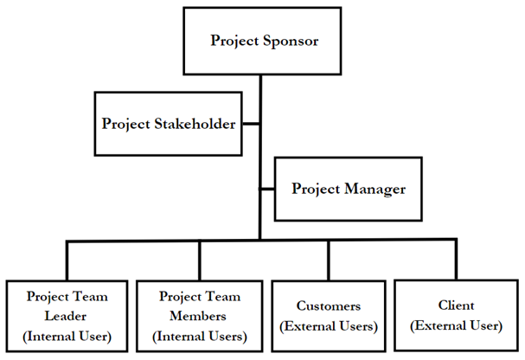

Figure 1: Project Organizational Chart

### **Staffing Management**

Staffing Management is a crucial part of ensuring the success of the project. It shows the plans and process of the project, managing the acquired information, and it also shows the responsibilities and task of the human resources.

* Acquisition must be completed as soon as possible to obtain the skills and knowledge required for the project. This will involve using new employees, outside contractors, and even internal staff as needed to complete the project.
* Prior to anything else, training will be used to reduce errors in the project working environment and to further hone skills for better application in the creation and execution of deliverables appropriately.
* Regular performance evaluations will be done to evaluate the performance of team members and pinpoint potential improvement areas. These evaluations also comment on the team members' performance in achieving the project's goals objectives and expectations.
* A recognition and incentive program will be put in place to reward and encourage exceptional performance. This could apply to rewards, promotions, and other advantages.

Regular reviews and updates to the Staffing Management Plan will be made as necessary to Ensure that it continues to be in line with the project's requirements and objectives. It is crucial that the project manager perform a thorough analysis of the project's particular requirements and laws to ascertain whether any extra items need to be added to the management of staffing.

|  |  |  |  |  |  |
| --- | --- | --- | --- | --- | --- |
| Role | Project Responsibility | Skills Required | Number of Staff | Performance Review | Recognition and Rewards |
| Project Sponsor | Approves the needed deliverables and budget of the project. | Strong leadership and strategic thinking skills. | 1 | Quarterly or as needed | Promotion or Bonus |
| Project Stakeholder | Organize meetings with the project manager and project team leader for the feedbacks of the project sponsor. | Strong leadership, communication skills, and project management skills. | 1 | Monthly or as needed | Promotion or Bonus |
| Project Manager | Control and help execute a solution to a problem in the project and monitors the work of the team members. | Strong leadership, communication skills. | 1 | Weekly or as needed | Salary Increase |
| Project Team Leader | Ensures that the entire project deliverables are complete.  Leads the Team members. | Strong leadership, communication skills. | 1 | Weekly or as needed | Salary Increase |
| Project Member | Ensures that the information in the deliverables is complete and connected to the objectives of the project. | Effective communication skills, technical skills, and cooperation. | Depend on the project requirement. | Weekly or as needed | Salara Increase |

Table 8. Staffing Management

## Change Management Plan

### **Introduction**

The Change Management Plan was created to facilitate the successful implementation of changes during the creation of the project. The plan is to outline the process and procedures of any changes that may arise such as schedule and cost. This plan will ensure that changes are rigorously evaluated, communicates, and implemented to minimize disruptions, adhere to the project’s plan, and maintain project success.

### **Change Control Board**

The Change Control Board is crucial to maintain stability, minimize risks, and to provide a structured and systematic approach to change management. By establishing a Change Control Board, the team MLNSD can initiate clear guidelines and procedures for handling changes Cost Management Plan.

The Change Control Board consists of representatives that are responsible for evaluating and approving or rejecting changes within the Villamin Wood and Iron Works Ordering System. The table below shows the roles and responsibilities of each representative for the modifications to the project plan:

|  |  |  |
| --- | --- | --- |
| Role | Name | Responsibilities |
| Project Sponsor/Business Owner | Manuel Villamin | * Communicates the need for change and gain support from stakeholders. * Approves the change management plan and ensures adequate resources are allocated. |
| Project Manager | Mabelle Aspeli | * Assesses proposed changes for evaluation, providing relevant information, analysis, and recommendations. * Implements approved changes and ensures they are properly integrated into the project plan and communicated to the team. |
| Team Leader | Leigh Curtis Camara | * Assists the project manager in assessing the impact of proposed changes on the team's tasks, deliverables, and timeline. * Implements approved changes within their team, ensuring clear communication, proper coordination, and timely execution. |
| Stakeholder | Sofia Emmanuelle Villamin | * Develop and deliver communication plans, messages, and materials to the project sponsor. * Participate in the change management process |

Table 9. Change Control Board

### **Roles and Responsibilities**

The change management process involves various roles and responsibilities to ensure a smooth transition and successful implementation of changes within the Villamin Wood and Iron Works Ordering System. The roles and responsibilities are shown below:

|  |  |  |
| --- | --- | --- |
| Name | Role | Responsibilities |
| Mabelle Aspeli | Project Manager | * Develops and implements the change management strategy and plan. * Identifies and manages potential risks and resistance to change. |
| Leigh Curtis Camara | Team Leader | * Works closely with the project manager and project stakeholder to implement the change initiative. * Assists in identifying and mitigating risks associated with the change. |
| Sofia Emmanuelle Villamin | Stakeholder | * Support and communicate the change to the team. * Comply with the changes and adapt their work practices accordingly. |
| Nathaniel Sison | Team Developer | * Collaborate with each of the team members to ensure the changes align with the project plans. * Design and implement the necessary code changes, integrations, or configurations. |
| Dale Joshua Domingo | Team Secretary/Developer Support | * Maintain documentation and records related to change management processes. * Provide technical support during the implementation phase and address any issues that arise. |
| Ludwig Angeles | Team Secretary Support | * Assist in Monitoring and tracking progress on change requests and ensure timely completion. * Contribute to the continuous improvement of change management processes. |

Table 10. Roles and Responsibilities

### **Change Control Process**

The change control process for the Villamin Wood and Iron Works Ordering System typically involves an organizational approach to managing any modifications, enhancements and implementing changes to the system.

1. Identification of Change - Any proposed change to the ordering system should be identified and documented.

2. Change Request Form - A change request form should be created to capture all the necessary details about the proposed change.

3. Change Control Board (CCB) Review – The project manager and team leader will review the change request. The evaluation process assesses the feasibility, impact, and risks associated with the proposed change. It may involve reviewing the system requirements, analyzing potential conflicts with existing functionality, and considering resource implications.

4. Impact Analysis – An impact analysis should be conducted to assess the effects of the proposed change on the ordering system. This analysis should identify any potential risks, dependencies, or conflicts with existing functionalities or components.

5. Change Approval – Based on the evaluation and impact analysis, the change control board decides whether to approve or reject the change request. If approved, the necessary resources and timelines are allocated for implementing the change.

1. Change Planning and Implementation – A detailed plan should be developed to implement the change. Implementation of change may involve development work, testing, configuration changes, or any other necessary actions.
2. Documentation and Communication - Throughout the change control process, documentation is maintained to track the changes made. Communication with the project sponsor and each of the team members is crucial to ensure awareness and understanding of the changes.
3. Change Closure: After the change has been reviewed and deemed successful, the change control process is considered complete.

To monitor the progression of change requests, the table below shows status for each phase.

|  |  |
| --- | --- |
| Status | Description |
| Submitted | A change request log will be submitted by a team member or project sponsor and will be conducted for impact analysis. |
| In Review | Evaluating the impact. |
| Approved | The change request has been reviewed, accepted and has been granted permission to proceed to implementation. |
| Denied | The change request has been denied for implementation. |
| In Progress | The approved change request is currently being implemented or worked on. |
| Verifying | The implemented change request is being verified to ensure it meets the desired outcome and requirements. |
| Closed | The change has been implemented, verified, and documented. |

Table 11. Change Control Process

## Communications Management Plan

### **Introduction**

This is a vital component of the project as the communications management plan outlines how the team will operate to fulfill the system, it outlines the strategy of the communication for the team and stakeholders.

The plan will discuss the type of information which will be communicated throughout the development which includes project updates, discussing progress report, risks, and issues with the project. The plan also specifies the communication needs of all parties involved and what the approach will be for the communication process to go accordingly.

### **Communications Management Approach**

The project manager is the one responsible for holding regular meetings with the project team and discussing the updates being made. These meetings will be held to ensure that everyone is aware of the progress of the project. The team should also establish a way to address any conflicts or issues that arise by communicating clearly.

### **Communications Management Constraints**

The Communications Management Constraints for the project are crucial to the overall project management plan because these constraints help in defining the limitations which may impact the communication processes and strategies created for the project. The team will look to develop solutions with the help of identifying the constraints to mitigate potential challenges. This section will provide an overview of the constraints that may impact the project’s communication strategies and processes. These constraints are the following:

Availability of team members - Some team members may have other work or responsibilities now making them unavailable to communicate.

Limited budget for resources and tools used for communication: The budget may not be sufficient to fund communication tools which can be used to improve the communication management plan.

Time conflicts - The deadlines provided may provide challenges in completing requirements and could result in conflicts with conducting regular meetings.

Technical difficulties - This may include internet problems and other technicalities that may be a constraint to communication processes.

### **Stakeholder Communication Requirements**

Video provides a powerful way to help you prove your point. When you click Online Video, you can paste in the embed code for the video you want to add. You can also type a keyword to search online for the video that best fits your document.

### **Roles**

|  |  |  |  |
| --- | --- | --- | --- |
| ROLES | AUTHORITY | RESPONSIBILITY | COMPETENCY |
| Project Sponsor | Approves the needed deliverables and budget of the project. Provides feedback and comments on what can be improved. Able to allot project resources and consent to project scope changes, schedule, and budgeting plan with significant effects. | Ensures that the project delivers the anticipated benefits and value and is in line with the organization's strategic goals and objectives. Provide guidance to the project and project manager. Communicate with the stakeholder and project manager for the progress of the project and team. | Communicating effectively with the team. Strong leadership and strategic thinking skills. Understands the team’s goal for the project. Ability to support the project. |
| Project Stakeholder | Checks the approved changes in the deliverables. Authority to revise an information that will mislead the goals of the project. | Ensures that the deliverables are complete before sending and having it checked by the project sponsor. Organize meetings with the project manager and project team members for the feedback from the project sponsor. | Strong leadership, communication skills, and project management skills. Knowledge of the company for precise information. |
| Project Manager | Authority to make decisions regarding the project. Approve changes to project scope, schedule, and budget that has low change effect. | Control and help execute a solution to a problem in the project and monitors the work of the team members. | Strong leadership, communication skills, and project management skills. Knowledge of the company for precise information. |
| Project Team Leader (Internal User) | Leads the team members. Authority to call a meeting with the project manager and team members about the project. | Ensures that the entire project deliverables are complete. | Strong leadership, communication skills, and project management skills. Knowledge of the company for precise information. |
| Project Team Members (Internal Users) | Authority to help the project leader and project manager in deciding the plans on the project. | Ensures that the information in the deliverables is complete and connected to the objectives of the project. Ensures that the deliverables are complete within the given period. | Effective communication skills, project management skills, and cooperation. Knowledge of the company needs, and information to complete deliverables. |
| Customers (External Users) | Evaluate the project’s system. | Provides feedback on the project’s system. Communicates with the team to help improve the system. | Strong leadership, communication skills, and negotiation skills. |

Table 12. Roles

### **Project Team Directory**

Video provides a powerful way to help you prove your point. When you click Online Video, you can paste in the embed code for the video you want to add. You can also type a keyword to search online for the video that best fits your document.

### **Communication Methods and Technologies**

The Villamin Wood and Ironworks System requires understanding from the team of the communication methods and technologies to effectively communicate with the stakeholders. It is essential to consider varied factors and limitations in ensuring that the stakeholders will receive the information they need at the right time and in an efficient manner. This includes delivering project updates, progress reports, and other relevant information. Some factors to consider are the location of the stakeholders, the level of technical expertise of the stakeholders which should be considered to factor in how the team should communicate. Also, the budget and resources available.

Based on the stated factors, it is important for the team to utilize the use of technologies such as project management software, email, telephone, and video conferencing for meetings.

### **Communications Matrix**

|  |  |  |  |  |
| --- | --- | --- | --- | --- |
| Communication Type | Purpose | Medium | Frequency | Audience |
| Initial Meeting | Introduction of the project team and the proposed project, presenting the objectives and the entire project plan. | Microsoft Teams | Once | * Project Manager * Project Team Members * Client |
| Team Meetings | Discussing the tasks and working on the deliverables. | Microsoft Teams  Face-to-face Meetings | Weekly | * Project Manager * Project Team Members |
| Progress Reports | Updating progress with the project and its deliverables. | Microsoft Teams  Face-to-face Meetings | Every other week | * Project Manager * Project Team Members |
| Sprint Meeting | To discuss the works that need to be completed and plan on how to accomplish. | Microsoft Teams  Face-to-face Meetings | Every other week | * Project Manager * Project Team Members |
| Technical Meetings | To discuss any technical issues regarding the project development and plan on how to resolve. | Microsoft Teams  Face-to-face Meetings | Only when needed | * Project Manager * Project Team Members |

Table 13. Communication Matrix

### **Communication Flowchart**

Video provides a powerful way to help you prove your point. When you click Online Video, you can paste in the embed code for the video you want to add. You can also type a keyword to search online for the video that best fits your document.

### **Guidelines for Meetings**

Meetings play an important role in facilitating effective communication. To guarantee productive, efficient and successful meetings, it is essential to set up meeting guidelines. These guidelines should elaborate on the details about the meeting’s purpose and the procedures to be followed in the meetings.

Below are the meeting guidelines to help in conducting effective meetings:

1. Purpose of the Meeting

- All meetings should define its purpose so that everyone understands what it is for and how important it is.

2. Goal of the Meeting

- The goal should be defined in a way that it is clear for everyone to know what should be accomplished during the meeting.

3. Minutes

- Minutes of the meeting is essential and should be taken during the meeting and provided to all involved parties as it entails the summary of everything that occurred in the meeting.

3. Attendance

- The people to attend the meeting should only include those who should be there, meaning only the people who can contribute in the discussions and the stakeholders who need to be informed.

### **Communication Standards**

Communication standards for the Villamin Wood and Ironworks System are the following:

1. Timely Response

- Respond to messages and emails efficiently to ensure that delays can be avoided.

2. Clear and Concise Messages

- Communicate information in this manner to ensure that the recipient of the message understands clearly without any confusion to avoid issues.

3. Use of Appropriate Communication Channels

- Select the appropriate communication channel or platform for each situation may it be an email, online meeting, or face to face meeting.

4. Regular Updates

- Keep the stakeholders informed about the project progress and other information which may require their attention.

**Communication Escalation Process**

Communication Escalation Process

The ideal Communication Escalation Process includes the following:

1. Identify the Problem

- This is the first step as the problem should be broken down an identified before we proceed to any escalation or resolution.

2. Look for a Resolution

- This can be done with the team to understand what caused the issues and look for the right ways to resolve it.

3. Escalate to Higher Management

- This only occurs when the issue cannot be resolved and requires further review from higher management.

4. Documentation

- It is important to document the entire escalation process from identifying the problem to its resolution.

5. Review Escalation Process

- This can be reviewed in order to learn from the previous issues and find ways to further improve and avoid those circumstances.

## Quality Management Plan

### **Introduction**

To ensure consistently high quality throughout the project, a quality management plan, and an agile methodology is needed to complete the requirements. The quality standards for evaluating the Villamin Wood and Iron Works project will be established by this plan. In addition, it offers a structure for resolving quality issues, illustrating the jobs and obligations of team members, and enumerating the standards and techniques connected with quality.

These are the goals of the quality of the management plan:

1. Ensure that the project meets or surpasses the expectations of stakeholders.

2. Determine the quality standards that will be used to evaluate the project.

3. Set up a system for managing and consistently maintaining the project's quality throughout its duration.

4. Identify and resolve any potential quality issues.

5. Make sure to define the roles and responsibilities of team members to attain quality standards.

The system implemented by Villamin Wood and Iron Works will prioritize user-friendliness and accommodation for the two clients and the actual business. It will seamlessly integrate with the organization's current technology, ensuring adaptability. The Quality Management Plan will encompass both product and process quality standards. It will include a comprehensive strategy with specific procedures and reporting for the overall overview of quality performance.

### **Quality Management Approach**

To guarantee that the project meets all following requirements and expectations of all stakeholders, the Quality Management Plan will provide a comprehensive system for effectively managing and maintaining the project's quality. To determine and address any quality issues which may arise, the plan will lay down a detailed set of procedures.

|  |  |
| --- | --- |
| Role | Description |
| Project Manager | accountable for ensuring that all deliverables are completed on time and that all stakeholders are pleased with the product. |
| Project Team Leader | responsible for ensuring that the team adheres to the Scrum principles and cooperates with Product Owner and Development Team to enhance the final product. |
| Project Development Team | Made contributions to accomplish the project objectives. ensuring that each deliverable is completed. Providing expertise and collaboration to define and satisfy business requirements to ensure the project's success. |
| Project Sponsor | is responsible for supporting the project and allocating financial resources. |

Table 14. Quality Management Approach

Every aspect of the project will involve the integration of quality management, which will be the responsibility of the entire team. Feedbacks and interaction from the client will be always the priority of the team to improve the project.

These are the following steps that include:

1. Define Quality Standards: The project team will prioritize delivering value to the customer by establishing quality standards that are in line with the principles of Agile Methodology.

2. Quality Planning: To determine the project's requirements and prioritize the best features, the team will maintain regular collaboration and schedule a meeting with stakeholders. This procedure includes creating the Product Backlog and establishing quality objectives to guarantee that the project transition produces value and abides by quality standards.

3. Quality Control: Quality control incorporates the most common way of looking into and testing to distinguish any potential issues that emerge at various stages. This system is done throughout the run to ensure that the established requirements and project goals are fulfilled.

4. Quality Assurance: The team will employ efficient methods and procedures to ensure that the project adheres to established standards and guidelines. To actively prevent issues and defects from occurring, they will implement quality assurance measures.

5. Continuous Improvement: The team consistently monitors its performance throughout the project's development to identify areas for improvement and make necessary adjustments. In this process, feedback plays a crucial role in involving stakeholders and fostering team collaboration. The team can identify areas that need improvement and improve the project's overall quality by actively seeking feedback.

6. Communication: Effective communication between the development team and stakeholders holds significant importance in this process. It serves multiple purposes, including updating stakeholders on the current quality status of the product, demonstrating alignment between the system's processes and the product's goals, and providing stakeholders with an opportunity to provide valuable feedback.

In conclusion, the Villamin Wood and Iron Works system project's quality management strategy will prioritize the delivery of a high-quality product that meets customer requirements by employing an Agile methodology. To go beyond meeting quality expectations, the approach will remain adaptable and continuously improved, and the team ensures that it is in line with the organization's quality standards and that it fulfills the requirements of the project stakeholders.

### **Quality Requirements/Standards**

The team creates and archive quality rules and guidelines that focus on the quality of the Villamin Wood and Iron Works Framework. Testing and evaluation, in addition to input from the client and stakeholders' feedback, will be incorporated to achieve this goal and guarantee compliance with the following criteria. The Villamin Wood and Iron Works System will meet the following quality standards and requirements:

*Product Quality Requirements:*

* The system will have user-friendly instructions and an interface, making it easy to operate and meet all the requirements for the project.
* The project will enhance business operations and align with the existing technology infrastructure.

*Requirements for Ensuring Quality of Processes:*

* The product owner and development team will carefully review and support any endeavor expectations before communicating to the customer.
* The improvement gathering will lead to typical run reviews to promptly recognize and decide on any quality concerns.
* To guarantee consistent system development, testing, and deployment, the development team will adhere to a specified configuration management procedure.
* The development team will set up continuous testing along with a quality assurance approach for making sure that the system complies with all technical requirements and requirements.

*Compliance Demonstrations:*

* Before deploying to the client, the group will evaluate and test the Villamin Wood and Iron Works system as per the characterized quality necessities and principles.
* On request, the client will have access to easily comprehensible documentation of all quality assurance and testing procedures. The development team will provide ongoing support to guarantee that the system consistently adheres to the established quality standards.

*Continual Improvement:*

* Continuous client feedback collection and analysis, system performance monitoring, and internal audits to find areas for improvement will all be part of the development team's continuous improvement process. This kind of setup will be incorporated into the venture to guarantee that the Villamin Wood and Iron Works System ensures quality standards are met as well as proactively adjusts to developing client needs.

### **Quality Assurance**

The Agile approach will be used to conduct the quality assurance approach for the Villamin Wood and Iron Works System project. This strategy aims to achieve appropriate implementation through consistent enhancement and teamwork. The following actions will be taken:

* Defining Quality Standards - To make sure that the deliverables meet the project's quality standards, the project team and stakeholders collaborated effectively.
* Quality Auditing – The team, with the collaboration of the stakeholder, will monitor and evaluate the quality of the project deliverables, ensuring adherence to established standards and specifications. The team will report and document findings to maintain records and communication with the stakeholders, Scheduling that will outline the initial plan and meet the deadlines, and continuous improvement to emphasize importance and better output of the project.
* Quality Metrics - The project team will monitor and report on how the project performed regarding the quality criteria, utilizing quality metrics.
* Continuous Improvement – With collaboration with stakeholders, the team will be able to identify areas for improvement and make significant changes. The project team will use the feedback from quality audits and quality metrics to continually enhance the product and the quality processes.
* Reviewing Customer Feedback - Customer feedback will be evaluated on a regular basis by the project team to find any issues or opportunities for improvement. To make sure that the product meets and exceeds customer expectations, this feedback will be used to guide ongoing improvement efforts.

### **Quality Control**

The process of quality control within the Villamin Wood and Iron Works System project will be established into the Agile approach with the goal of ensuring that quality meets expectations through teamwork and continuous development. These are the following steps that involve in the project:

* Continuous Testing and Feedback - To identify any issues and assure that the product corresponds to the demands of the client, the project team is going to perform a continual evaluation.
* User Acceptance Testing: To ensure that it aligns with client requirements and demands, the project manager or developer will monitor the system’s functionality. This phase will be finished at the end of each sprint, and user feedback will be used to make any necessary improvements.
* Compatibility Testing: The Villamin Wood and Iron Works System will undergo testing across several phases, including mobile devices and any browser, to confirm consistency and manage any potential problems within the system.
* Continuous Monitoring: The project team will carefully monitor the performance and effectiveness of the Villamin Wood and Iron Works system following its installation. This requires constant performance and functioning system monitoring.
* Tracking and Documenting Quality Evaluations: The project team will adhere to, and the outcomes of the Quality Control procedure will be preserved and used to monitor the activities or progress of the system.
* Continuous Improvement: The Quality Control procedure aims to identify opportunities for development and make any required adjustments.

In summary, the Villamin Wood and Iron Works System project's quality control system is going to be essential to the development process. It will emphasize monitoring the overall performance. As part of the quality control process, the project team will diligently monitor and assess the product's quality, ensuring the required quality standards and customer requirements.

### **Quality Control Measurements**

The Villamin Wood and Iron Works System project will employ the Agile Methodology throughout its life cycle to enable continuous review and improvement. To guarantee effective quality control, this plan will place a strong emphasis on transparency and cooperation.

The Quality control procedures will be applied at every phase of the development process to ensure compliance with standards and requirements. These measures will be documented and available on a platform for collaboration and documentation, like an application for project management.

## Risk Management Plan

### **Introduction**

In this project, the risk management plan aims to breakdown and identify the potential risks that might be there for the project. That is why the risk management plan is being developed to response to those potential risks and also manage those risks by ensuring that the project team can mitigate it as we achieve the project’s objectives.

The risk management plan includes an overview of the risk management process, showing the roles and responsibilities of the project team and the risk assessment approach. It is key to be able to identify all the potential risks and as a team be able to develop resolutions for it.

### **Top 3 Risks**

The project’s top three risks are:

1. Technical risks which may occur due to delays in development of the project or technical issues. This may result in issues with the budget and delay in the project timeline as well.

2. Resource risks which may occur when there are insufficient resources which may be needed for further development.

3. Security Risks which may occur when there is a data breach or any other form of hacking of the system.

### **Risk Management Approach**

The risk management approach focuses on quickly identifying the potential risks and composing mitigation plans that are capable of handling and resolving the risks that may occur. All stakeholders will be included in this risk management process as it requires a cooperative approach and contribution from everyone involved.

### **Risk Identification**

The risks identified in the risk assessment were updated and regularly monitored to ensure that they are being managed effectively.

Some of the potential risks identified in the risk assessment are listed below:

* Technical Risks – There is a risk that the project may be delayed due to technical reasons.
* Resource Risks – There is a risk that the project may not have access to enough resources causing a stop of work or adjustments in budget or other delays.
* Security Risks – There is a risk of being hacked and having a breach in the system.
* Changes in Technology – There is a risk that a change in the industry of technology occurs which may require additional work or resources to adapt.
* Human Error – There is risk that a person may commit a mistake or error that could negatively affect the project.
* Unforeseen Circumstances – There is a risk that circumstances such as natural disasters could cause disturbance and impact the project in an unexpected way.

To mitigate these risks, the team has developed a plan which will mitigate all risks and monitor them all in the process as to protect the project avoid all risks.

### **Risk Qualification and Prioritization**

Video provides a powerful way to help you prove your point. When you click Online Video, you can paste in the embed code for the video you want to add. You can also type a keyword to search online for the video that best fits your document.

### **Risk Monitoring**

Risks will always be present especially during the project’s life cycle which is why it is important to continuously monitor those risks and document the entire process which includes identifying the conditions which may trigger certain risks.

As for the plan, the project manager will incorporate and assign a risk manager to oversee the monitoring process which will help the team to determine if the risks require a higher level of attention in case the risks trigger. The risk manager will provide report updates during team meetings to keep everyone updated.

Furthermore, it should be noted that not only the risk manager should pay attention to any risks around the project, but the entire project team should also remain aware of the identified risks and the potential they have to impact the project which is why everyone is encouraged to help and notify the project manager or risk manager in case new risks occur.

### **Risk Mitigation and Avoidance**

The risk management plan will be created by the team based on the criteria created rating the risks based on their impact and importance. In preparation for those risks, the project team will collaborate alongside with stakeholders to put mitigation techniques in place to mitigate the risks.

To accomplish risk mitigation and avoidance the team should identify the potential risks and prioritize what to manage first based on the severity of its impact. Provided below are considerations or options available for the project manager to avoid and mitigate the risks:

* Resource Allocation - Guaranteeing that the project has all the required resources is crucial for the project to be successful and efficient which is why resource allocation is important to ensure that the resources are available to the team to finish the project.
* Risk Assessment - The team needs to analyze potential risks effectively to anticipate it and immediately apply resolutions.
* Contingency Planning: To be prepared for potential risks, the team needs to produce multiple backup plans in case some may not work due to some reason in each scenario.
* Communication: It is important for the entire team to be able to communicate clearly and prevent misunderstandings as it has the potential to create risks. Having clear communication between the project team, clients, and stakeholders can help minimize these risks.

### **Risk Register**

The risk register includes a thorough explanation of each risk and its potential effects, as well as the mitigation steps taken. The risk register will be maintained up to date throughout the project to make sure that it reflects the project’s current condition.

## Procurement Plan

### **Introduction**

A procurement plan is a vital component of any organization's strategic planning process, as it outlines the approach and strategy for acquiring goods, services, or works from external sources. It serves as a roadmap that guides the procurement activities, ensuring that the organization obtains the necessary resources efficiently, effectively, and in compliance with relevant regulations and policies.

It considers the organization's overall objectives, budgetary constraints, and specific project requirements. The plan outlines the procurement methods, timelines, and responsibilities for each procurement activity. The primary purpose of a procurement plan is to ensure transparency, fairness, and value for money in the procurement process. By having a well-defined plan in place, organizations can mitigate risks, avoid unnecessary delays, and maximize the benefits of their procurement activities.

The procurement plan shows the details of multiple suppliers that can be managed by the company, and the approval process in the contract. The plan also includes the decision criteria, establishment of contract deliverables and schedule of deadlines, which explains the contracts that are coordinated with the project scope, budget, and schedule.

Overall, Organizations must have a well-developed procurement strategy in place if they want to accomplish their goals methodically and affordably. Transparency, fairness, and value for money are ensured by the structured framework it provides for the procurement of goods, services, or works. Organizations can streamline their procurement processes, lower risks, and guarantee that the acquisition of goods and services is conducted in a transparent and effective manner by creating a thorough procurement plan.

### **Procurement Risks**

Procurement risk are potential problems that could issues that could potentially harm the project's success come up during the procurement process. To reduce these risks, it is crucial to recognize them and take initiative-taking measures to address the influence over the project.

The Villamin Wood and Iron Works System project may contain procurement activities that carry risks which are included but not limited to the following:

1. Changes to the project's scope, schedule, or budget, which may have an impact on vendor commitments and procurement activities.
2. Unclear and insufficient information in the documentation that may leads in misunderstanding between the team and the client.
3. Incomplete contract terms or legal issues that will affect the project’s reputations and legal rights.
4. Lack of communication and transparency between the team and the vendors, which may lead to misunderstanding.

To lessen the impact of the risks, this plan will include strategies for identifying, evaluating, and reducing risks. Throughout the course of the project, this plan will be continuously reviewed and updated to make sure that risks are recognized and promptly addressed. Furthermore, we will put into practice strict processes and procedures for reducing the risks involved in procurement management.

### **Procurement Risk Management**

1. Identification of Procurement Risks

The following are the potential risks of the project:

* Sudden change in cost of goods and services
* Lacking information of contract’s terms and conditions
* Misunderstanding due to misinformation from the team to the vendor about the project

1. Risk Mitigation Strategies

The following are the strategies that will be implemented:

* Thoroughly research the identity of the company supplier and their goods and services.
* Conduct meetings as much as possible for communicating reports to clear confusion about the project.
* Establish clear and fair contract terms and conditions that will protect the company and the project.
* Regular monitoring throughout the procurement process to ensure that the team will be ready for any emerging risks.

1. Assignment of Responsibilities

Villamin Wood and Iron Works System needs a clear roles and responsibilities to help ensure accountability, clarity, and effective coordination. It is essential to clearly communicate the assigned responsibilities to all parties involved and ensure that everyone understands their roles and obligations. Regular communication, coordination, and collaboration among the responsible parties contribute to the smooth execution of the procurement plan and successful procurement outcomes.

1. Communication and Reporting

Effective communication and reporting play a crucial role in ensuring transparency, coordination, and accountability throughout the procurement process. Regular and clear communication helps stakeholders stay informed, aligned, and engaged. It enables the exchange of critical information, progress updates, and timely resolution of issues.

This ensures that relevant stakeholders are kept informed about procurement activities, supplier selection processes, contract status, and any potential risks or issues. It will promote collaboration, enable timely decision-making, and provide a platform for addressing concerns, feedback, and suggestions.

1. Continuous Improvement

Continuous improvement is a fundamental aspect of the procurement process, driving efficiency, effectiveness, and innovation. Lessons learned from past procurement experiences will be documented and shared to avoid repeating mistakes and capitalize on best practices.

The procurement plan will emphasize the commitment to continuous improvement as an integral part of the procurement lifecycle, ensuring that the organization remains adaptive, responsive, and proactive in meeting evolving needs and achieving excellence.

### **Cost Determination**

Villamin Wood and Iron Works System’s cost determination is a critical aspect of the procurement process, ensuring that the organization obtains goods or services at the most favorable price while maintaining quality and meeting requirements. When calculating the project's overall cost, it is important to take project management, development, integration, procurement, training, maintenance and support, contingency, and operating expenses into account.

Project management-related expenses for personnel, hardware, and software are all included. While integration costs cover the price of integrating the system with other programs or third-party applications, development costs cover the cost of creating software, hardware, testing, and quality assurance. The price of purchasing the necessary tools, software, and services to design and put the system into use is included in the procurement costs. The costs associated with training personnel to use the system effectively are also covered.

This includes conducting thorough cost analysis, considering the total cost of ownership, conducting market research and benchmarking, engaging in effective cost negotiation, and maintaining cost transparency and documentation. By employing these strategies, the procurement team can make informed decisions, optimize cost savings, and achieve value for money while procuring goods and services that meet the organization's needs and quality standards.

Overall, the procurement management plan's cost determination section will have a crucial role in ensuring the completion success of Villamin Wood and Iron Works System project within the given budget constraints.

### **Procurement Constraints**

Procurement constraints are inherent limitations and factors that can influence the procurement process and pose challenges to achieving procurement objectives. The following constraints are considered in Villamin Wood and Iron Works System project’s procurement process:

1. **Budget constraint:** The project was given with a limited financial resource by the client. This requires careful budget planning and cost optimization strategies to ensure procurement objectives are met within the allocated budget.
2. **Schedule constraints:** The project has a strict deadline, so procurement tasks must be finished promptly to keep the project on schedule. Any delays in the procurement process could affect the project's overall schedule and cause it to take longer to complete.
3. **Technology constraints:** Villamin Wood and Iron Works System requires technical needs and features that will allow customers to view products and services, to be able to order and pay for their products. Additionally, it must have a user-friendly interface that is simple to navigate and open to users with different levels of technical proficiency.
4. **Resource constraints:** To ensure that procurement activities can be completed effectively and efficiently, the procurement process must consider the availability of internal resources, such as personnel.

By recognizing and proactively addressing these constraints, organizations can navigate the procurement landscape more efficiently and effectively, leading to better decision-making, cost optimization, and overall procurement success.

### **Contract Approval Process**

The contract approval process is a critical step in the procurement lifecycle, ensuring that contracts are reviewed, authorized, and executed in accordance with established policies and procedures. These procedures include the following:

* **Contract Initiation:** The procurement process will be initiated by the project manager by sending a Workday request for procurement to the procurement officer.
* **Contract Planning:** A procurement plan that specifies the kind of contract to be used, the evaluation standards, and the deadlines for procurement activities will be created by the procurement officer.
* **Contract Development**: The procurement officer will create the contract documents, such as the Terms and conditions, a pricing schedule, and a Statement of Work (SOW) after the procurement plan has been approved.
* **Contract Review:** The legal department will examine the contract documents to make sure they adhere to all relevant laws and rules.
* **Contract Approval:** The Contract Review Committee will be asked to approve the contract documents. The Committee will then assess the contract documentation and provide the Project Manager with a recommendation.
* **Contract Execution:** The Procurement Officer will execute the contract and issue a purchase order during the Workday after it has been approved.
* **Contract Monitoring:** To make sure the vendor is observing the terms of the contract, the project manager will monitor their performance. Additionally, the procurement officer will keep an eye on the agreement to make sure that all deliverables are fulfilled, and payments are made in accordance with the contract's terms.

Overall, by establishing a clear and structured contract approval process, organizations can enhance transparency, accountability, and efficiency in their procurement activities, minimizing potential legal and financial risks while fostering effective supplier relationships.

### **Decision Criteria**

Decision criteria are a set of predefined factors and considerations used to evaluate and make informed decisions in the procurement process. The following are the criteria for the Villamin Wood and Iron Works System project that will be used by the contract review board:

* **Schedule:** The vendor must show they can complete the project on time and meet all deliverables, including important deadlines and milestones.
* **Business Needs:** The project must be aligned with the company’s business needs, such as increasing operational effectiveness, enhancing customer experience, or an increase in revenue.
* **Pricing:** During the decision-making process, the cost of the vendor's suggested solution will be considered. The vendor's pricing should be competitive and reasonable considering the market analysis and additional proposals received.
* **Risk Management:** The vendor must show that they have a solid grasp of potential risks and mitigation techniques. This includes identifying potential risks associated with projects and procurement.
* **Technical Requirements:** The system must adhere to the organization's technical specifications, which may include compatibility with current systems, security protocols, and industry-specific standards.
* **Compliance:** The vendor must comply with all applicable laws, rules, and agreements, including those relating to intellectual property rights, data privacy, and security.

The use of clear and well-defined decision criteria promotes consistency, transparency, and accountability in the procurement decision-making process, enabling organizations to make informed choices that yield favorable outcomes.

### **Performance Metrics for Procurement Activities**

The following performance metrics will be used by Villamin Wood and Iron Works System project for procurement activities:

1. Vendor Performance Rating

The rating is calculated by giving points to various factors, including the caliber of the good or service, responsiveness, and communication. A rating scale of 1 to 5, with 5 being the best, can be created by averaging the total score.

1. Customer Satisfaction

Customer satisfaction with the purchasing process, including receptivity, communication, and product and service delivery.

1. Procurement Cycle Time

The length of time needed to complete the procurement process from need identification to the issuance of a purchase order or contract.

1. Cost Variance

This metric contrasts actual and anticipated costs associated with procurement. To calculate, divide the result by the planned costs after deducting the actual costs.

1. Contract Management

The success of contract management procedures like contract extensions, modifications, and supplier performance evaluation.

By establishing and monitoring performance metrics, organizations can track their procurement performance, identify areas for improvement, and make data-driven decisions to optimize procurement activities. Performance metrics enable organizations to gauge the value and impact of their procurement efforts, drive continuous improvement, and ensure alignment with strategic objectives.

## Implementation Plan

### **Executive Summary**

Video provides a powerful way to help you prove your point. When you click Online Video, you can paste in the embed code for the video you want to add. You can also type a keyword to search online for the video that best fits your document.

### **Transition Approach**

The Villamin Wood and Iron Works System addressed the Transition Plan, in which there will be a phase or transition that should be followed for continuity and to reduce any operational challenges or interruptions that they encounter. This precise and systematic approach enables the transfer of knowledge, resources, and responsibility to the business company, thereby reducing all possible technical interruptions.

The transition approach will include the following steps:

1. Communication Plan – the stakeholders will be able to familiarize themselves with the transition plan as a result, resulting in a better comprehension of project timelines and transition expectations.

2. Staffing - As the transition takes place, the project team will minimize their staff to the necessary level needed for supporting knowledge transfer and transition activities.

3. Transition Planning – A transition plan can be completed by interacting with the company, the team followed the timeline in which all requirements and process is required to be completed for the time of transition.

4. Knowledge Transfer - A variety of approaches, including documentation and direct demonstrations, will be used to facilitate knowledge transfer.

These initiatives seek to provide Villamin Wood and Iron Works with the skills and knowledge they need to provide effective system support.

*Assumptions*

The following assumptions will be made for the transition approach:

1. If any difficulties arise during the deployment process, the team will maintain communication with the company.

2. To make it easier for the client to learn, the project team will provide them with all the necessary documentation, training, and instruction manuals.

3. Once the transition is finalized, the team will engage in a discussion with the client and continue to assist the owner, aiming to gain a deeper comprehension of any concerns related to the system.

### **Transition Team Organization**

*Roles and Responsibilities*

1. Project Manager -The responsibility of the project manager leads this project to its completion. The project manager guarantees to meet all the requirements, setting a plan for the deadline of deliverables, and speaking with the client is effective to ensure progress.

2. Project Stakeholder - responsible for allocating the required resources to guarantee the success of the project. Assuming responsibility for the relevant tasks and objectives. Staying updated on the project's advancements and sharing relevant information with the necessary individuals. Taking initiative-taking steps to identify and fulfill training and development needs.

3. Project Sponsor - the project sponsor has the authority for the system's overall development process, including approval before changes, budget, project scope, and schedule.

4. Project Developers – is responsible for the project's design and development into action. Also, the developer is most likely to collaborate with the new owner for general comprehension of the process before the transition of technical knowledge.

5. Project Team - responsible for all deliverables such as documentation, planning, and implementing project schedules.

### **Workforce Transition**

The workforce transition is part of the transition plan for the Villamin Wood and Iron Works System. To establish the transition, and run efficiently, the team planned to evaluate to determine if there are issues that may arise.

To determine whether the transition will be conducted appropriately for the workforce, the Transition Project Manager will work closely with the store manager and the business owner.

In general, effective communication is essential for fostering teamwork and informing the client of any changes. The group will provide user-manual and conduct demonstrations to ensure smooth operation and highlight how this system will be beneficial to the company. The workforce transition will be evaluated on a regular basis to guarantee that the project is moving forward in a timely and cost-effective manner.

### **Workforce Execution During Transition**

While the change time of the Villamin Wood and Iron Works system is in progress, certain undertakings will, in any case, should be completed, including the following:

* User Training - The team will provide instructions or materials to follow to make sure the customer understands how the system works. The training environment can include online and face-to-face interactions to achieve a more comprehensive comprehension.
* Minutes of the Meeting - During this phase, online meetings will be held to discuss any remaining project concerns. All team recordings will be included in the transition, and prior to the actual meeting, meetings between the team and the company will be scheduled.
* Update Files/Records - The team will make any necessary adjustments to all relevant records and files to show that the project is finished. This could mean storing documents or updating agreements and contracts with added information.
* Gain Formal Acceptance - In this phase, the team is responsible for ensuring all requirements have been fulfilled with the newly implemented system. Also, the objective of this phase is to get the client to officially acknowledge that the transition went well.
* Archive Files/Documents - The process includes storing all project-related documents and files during this stage. Contracts, agreements, project plans, and other relevant documents might all fall under this category.
* Project Close-Out Meeting - The last phase of the change will involve directing an undertaking conclusion meeting with all participants. This gathering will be an opportunity to talk about the project, look at its overall presentation, highlight its successes, point out areas that need improvement, and confirm the purpose of any work that has not been completed.

### **Subcontracts**

This project has no existing contracts or subcontract agreements. As a result, no contract or related agreement changeover is necessary.

### **Property Transition**

#### **Government Furnished Equipment (GFE)**

This section of the transition plan is not applicable since Government Furnished Equipment (GFE) is not involved in the Villamin Wood and Iron Works Ordering System.

#### **Incumbent Owned Equipment**

All equipment owned by the incumbent will remain upon completion and approval of the Villamin Wood and Iron Works Ordering System. Any equipment needed to support the client's applications and services should be specified in the plan, including whether the client or the new contractor will have the choice to purchase it.

The plan must include all necessary documentation, such as purchase agreement, bill of sale, financial statements, permits, licenses, registrations, and all necessary documents and procedures must be followed accurately and in compliance with local laws and regulations.

#### **Intellectual Property**

#### **User Accounts and Passwords**

The company, Villamin Wood and Iron Works, pointed out that they do not directly collect or store usernames and passwords for customer accounts. Instead, they use a third-party platform, like Facebook page, to connect with customers and provide access to their services. Customers are urged to check in with their Facebook credentials already in place to avoid creating new accounts or passwords. This strategy guarantees a secure and seamless user experience while protecting client privacy.

The integration of the system with the Facebook platform, as well as proper configuration and adherence to their rules, will be the primary focus during the implementation phase. Customers will be given detailed instructions on how to log in using their Facebook accounts, emphasizing the significance of protecting their login information. The company prioritizes the integrity and security of client accounts while boosting convenience and user happiness by utilizing Facebook's well-established security procedures.

Although user accounts are present on Facebook, Villamin Wood and Iron Works do not collect details other than Usernames, and User Profiles. This means that the team will not be able to transfer Facebook credentials such us User Accounts and Passwords to the proposed system.

#### **Knowledge Transfer**

Documentation/Manuals:

* The project team will provide documentation and manuals for the Villamin Wood and Iron Works company for better understanding regarding the operation of the system.
* The team will provide manual that contains step-by-step instructions on how to perform operation regards to the system. This will allow the store owner or manager easy to operate the system.
* The team will provide documentation and other relevant documentation for the company for better understanding to the system and on how it works.

As part of the Knowledge Transfer Plan, the project team and the store owner/manager will be scheduling for a meeting to ensure that knowledge transfer is successful, and any questions or concerns will be address urgently. Any changes regard to the system, the company will inform to ensure that they are updated.

#### **Schedule**

Figure 2. Transition Out Schedule

#### **Handover and Acceptance**

The process of handover and acceptance will start if the transition plan is completed. The team will set a schedule for the formal handover and meeting with the new owner and employees to discuss about the transition plan. This will include all the deliverables and documents.

During the handover meeting, all required documents and deliverables must be completed wherein the team will present the transition plan accordingly to the company then they will further review the materials that was provided and discuss if there are any concerns regarding to the requirements. The formal acceptance document will be only sign if the company owner resolved all the issues. This will serve as an agreement and evidence that the handover has been successful alongside with the signatures of the stakeholders.

Overall, the handover and acceptance of section of the contract transition out plan contains detailed roadmap for the successful handover and ensure that all the stakeholders contented to the process or the outcome of the project.

# Sponsor Acceptance

Video provides a powerful way to help you prove your point. When you click Online Video, you can paste in the embed code for the video you want to add.

Sponsor Acceptance

Approved by the Project Sponsor:

Date:



(List of Tables)

(List of Figures)

# Appendices

## Project Cost and Benefit Analysis

Video provides a powerful way to help you prove your point. When you click Online Video, you can paste in the embed code for the video you want to add. You can also type a keyword to search online for the video that best fits your document.

## Project Methodology

Video provides a powerful way to help you prove your point. When you click Online Video, you can paste in the embed code for the video you want to add. You can also type a keyword to search online for the video that best fits your document.

## System Requirement Specifications

Video provides a powerful way to help you prove your point. When you click Online Video, you can paste in the embed code for the video you want to add. You can also type a keyword to search online for the video that best fits your document.

## Development Tools Specifications

Video provides a powerful way to help you prove your point. When you click Online Video, you can paste in the embed code for the video you want to add. You can also type a keyword to search online for the video that best fits your document.

## WBS Dictionary

Figure 3. WBS Dictionary Page 1

Figure 4. WBS Dictionary Page 2

Figure 5. WBS Dictionary Page 3

Figure 6. WBS Dictionary Page 4

Figure 7. WBS Dictionary Page 5

Figure 8. WBS Dictionary Page 6

Figure 9. WBS Dictionary Page 7

## WBS Detailed Schedule

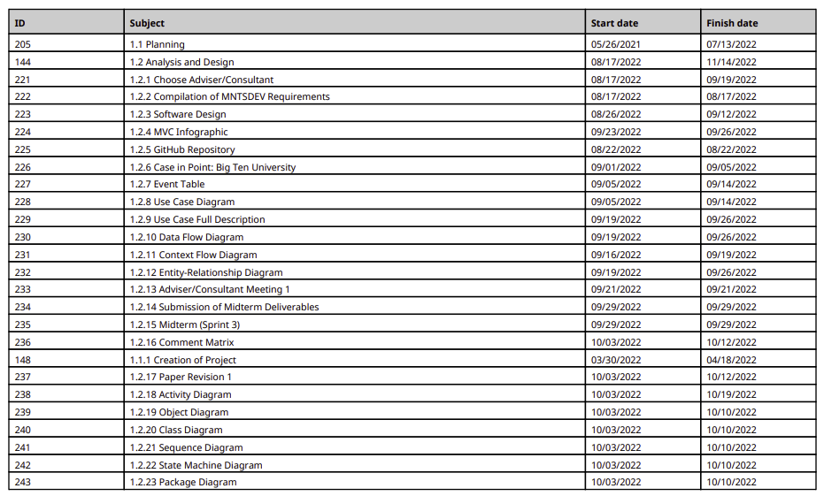

Figure 10. WBS Detailed Schedule Page 1

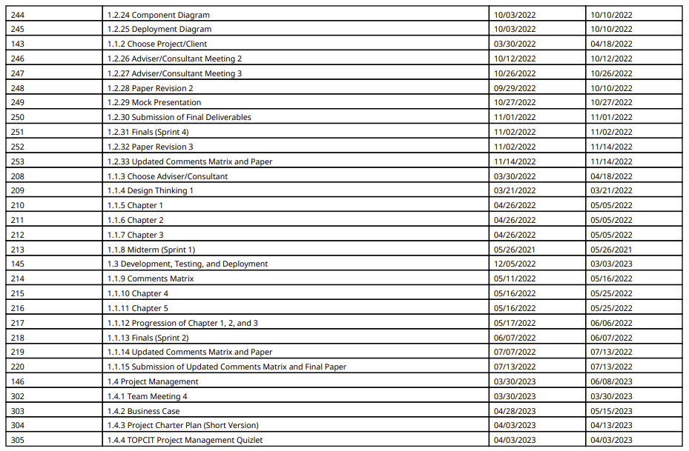

Figure 11. WBS Detailed Schedule Page 2

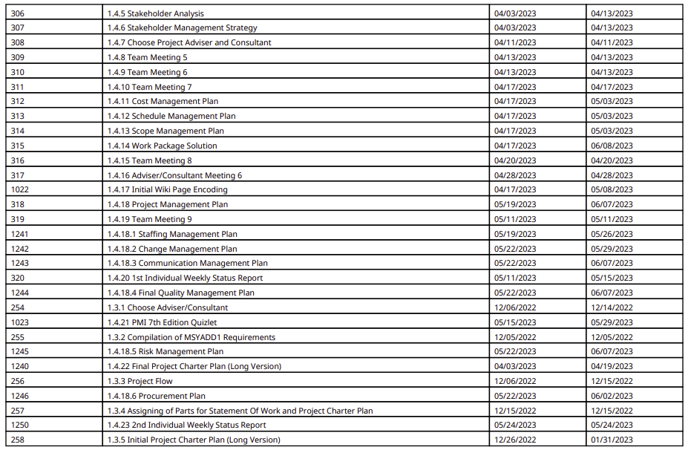

Figure 12. WBS Detailed Schedule Page 3

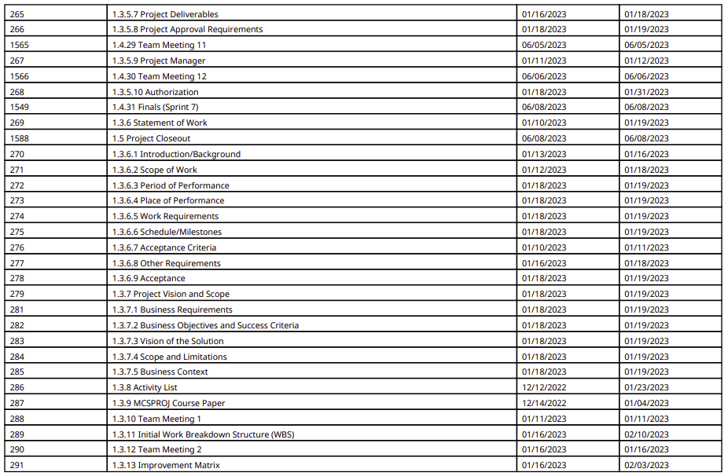

Figure 13. WBS Detailed Schedule Page 4

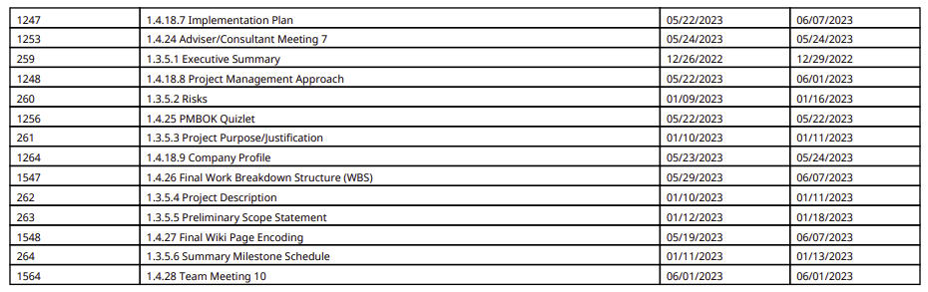

Figure 14. WBS Detailed Schedule Page 5

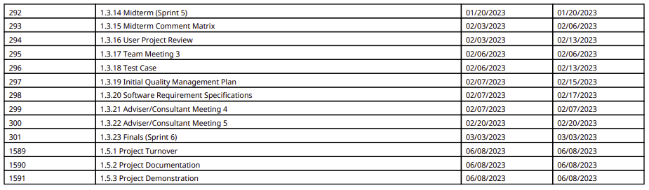

Figure 15. WBS Detailed Schedule Page 6

## Detailed Cost Estimates

Figure 16. Detailed Cost Estimates